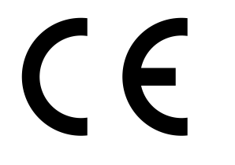
EC Declaration of Performance

Lime Green Products Ltd, Coates Kilns, Stretton Road, Much Wenlock, Shropshire, TF13 6DG

13

EN 998–1:2010

General purpose (GP) rendering mortar for external use

Reaction to fire: Class A 1

Adhesion: 0.9 N/mm2 FP: b

Capillary Water absorption: W0

Water vapour Permeability coefficient. ≤15

Thermal conductivity λ10,dry [W/mK] P=50% 0.67
P= 90% 0.76

Durability: (against freeze/thaw): evaluation based on provisions valid in the
intended place of use of the mortar

Lime Green Natural Stipple

Date 28/8/13

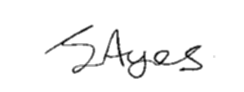
Signed

J Ayres – Director

